A000-Eur-Norway-Viking-Pendant-Head of Norse Warrior-Silicified Sandstone-950 CE

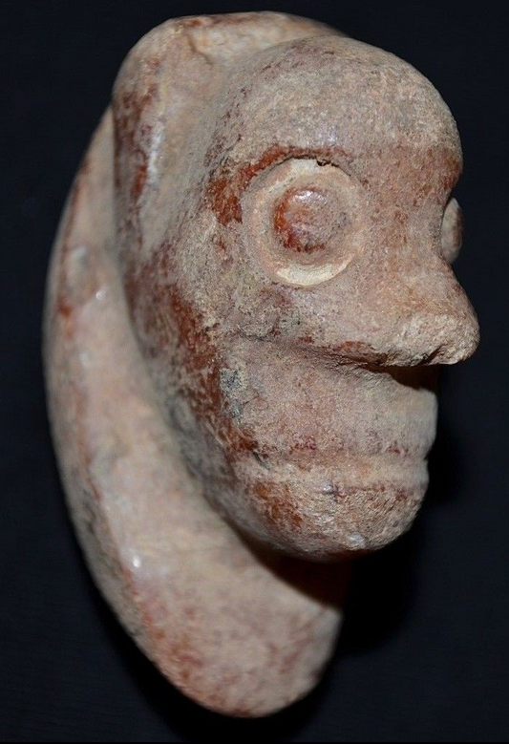 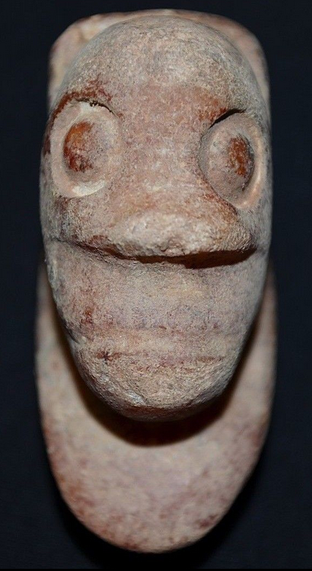 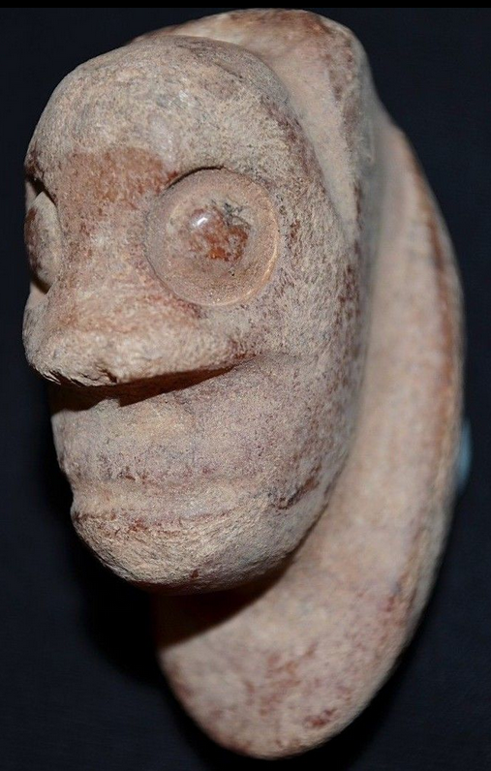

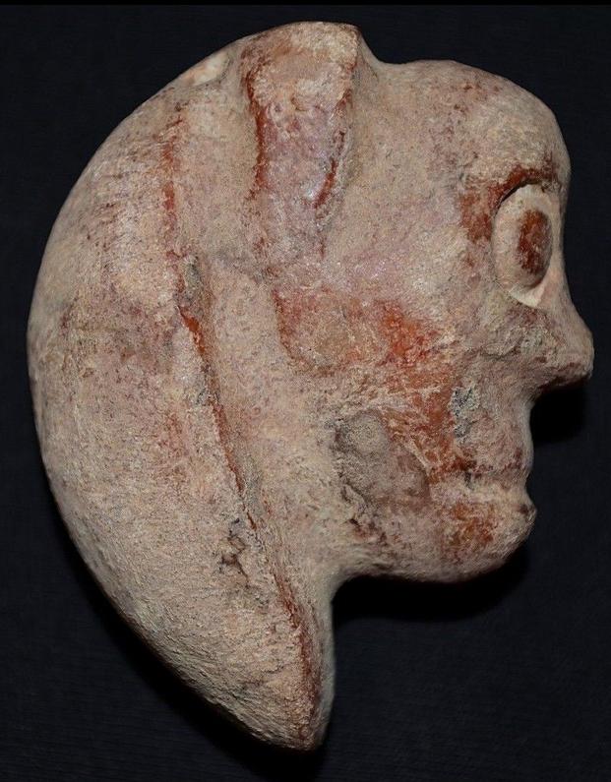 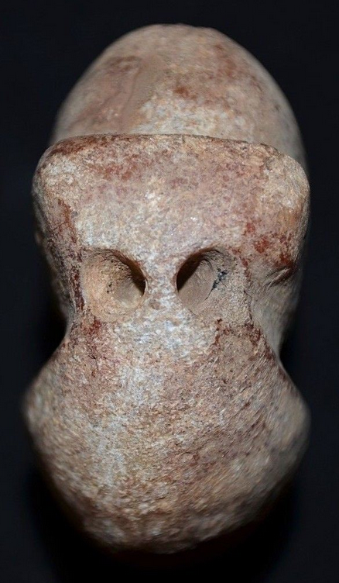 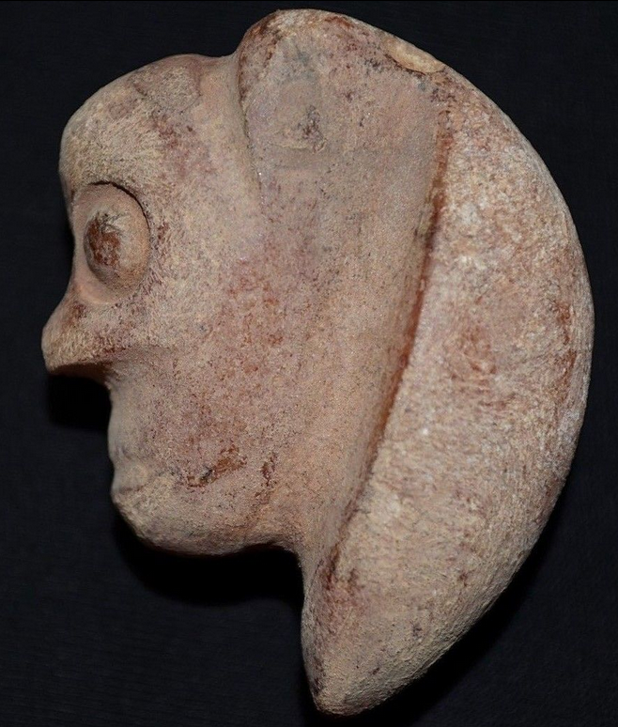

Figs. 1-6. Norway-Viking-Pendant-Head of Norse Warrior-Silicified Sandstone-950 CE

**Case no.: 4**

**Accession Number:**

**Formal Label:** Norway-Viking-Pendant-Head of Norse Warrior-Silicified Sandstone-950 CE

**Display Description:**

Finely carved from silicified sandstone, very fine and delicate, an amazing specimen. The wide-open eyes suggest the electric stance of a warrior about to go into battle with full vision of the perceived enemy An incredible piece of ancient stone sculpture. Very high quality. Rare

**LC Classification:** DL444.1.

**Date or Time Horizon:** 950 CE

**Geographical Area:** Norway

**Map:**

**GPS coordinates:**

**Cultural Affiliation:** Norwegian Viking

**Medium:** slate

**Dimensions:** H 50 mm

**Weight:** 64.4 gm

**Condition:** excellent. Minor scrapes and dings. Light staining and earthen deposits, mostly on the underside.

**Provenance:**

Yanko Ardenski

273 A Eltham High Street

Eltham

London

SE9 1TY

United Kingdom

Phone:07842936467

Email:yankoardenski@gmail.com

**Discussion:**

**References:**

Theodoricus, Monachus. 1998 [1188]. *Historia de antiquitate regum Norwagiensium = An account of the ancient history of the Norwegian kings*. London: Viking Society for Northern Research, University College London.